**Digital System Design Lab CSE-308L**

**Semester:6th**



**Lab Report # 8**

**Digital lock using fsm**

**Submitted By:** *Zainab Khalid*

**Registration No:***19PWCSE1743*

**Section: A**

**Submitted to:** *Mam Madeeha Sher*

**Department of Computer Systems Engineering**

**University of Engineering and Technology Peshawar**

**LAB 8**

**A DIGITAL LOCK**

**OBJECTIVE:**

Build an electronic combination lock with a reset button, two number buttons (0 and 1), and an unlock output. The combination should be “01011”

**BLOCK DIAGRAM:**

A combinational digital lock has three input buttons for Reset, entering a “0” and entering a “1” and the output button UNLOCK and state which shows in which state the machine is currently in. The state output is connected to the seven-segment display on the S6BOARD. The Module button in the below diagram is an abstraction of the synchronizer and level-to-pulse converter from the previous lab. The state transition diagram is given in the following figures.

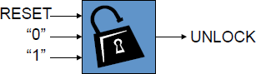

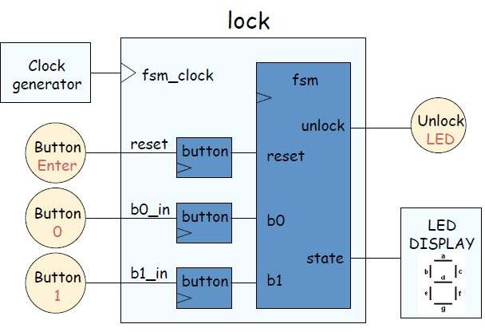

**STATE TRANSITION DIAGRAM:**

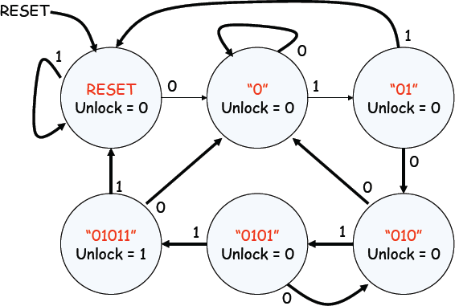

**LAB TASKS:**

1. **Change the functionality of the lock such that it unlocks on the sequence of 11011.**

**CODE:**

module lock(clk,rst,on,off,out,one,zero,segcode,en);

output reg out;

input clk,rst,on,off;

output one,zero,en;

output segcode;

wire synin, CLK_1hz;

reg [2:0]state, next_state;

wire [6:0]segcode;

CLOCK_Divider CD1(clk,rst,CLK_1hz);

synchronizer ss1(on,CLK_1hz,rst,synon);

synchronizer ss2(off,CLK_1hz,rst,synoff);

level2pulse t1(CLK_1hz,rst,synon,one);

level2pulse t2(CLK_1hz,rst,synoff,zero);

sevensegment seg(state,segcode);

assign en = 0;

parameter s0=0;

parameter s1=1;

parameter s2=2;

parameter s3=3;

parameter s4=4;

parameter s5=5;

always @(posedge CLK_1hz)

begin

if(~rst)

begin

state=s0;

end

else

state=next_state;

end

always @(*)

begin

case(state)

s0:

begin

if(one)

begin

next_state=s0;

out=0;

end

else if (zero)

begin

next_state=s1;

out=0;

end

else

begin

next_state = state;

out = out;

end

end

s1:

begin

if(one)

begin

next_state=s2;

out=0;

end

else if(zero)

begin

next_state=s1;

out=0;

end

else

begin

next_state = state;

out = out;

end

end

s2:

begin

if(one)

begin

next_state=s0;

out=0;

end

else if(zero)

begin

next_state=s3;

out=0;

end

else

begin

next_state = state;

out = out;

end

end

s3:

begin

if(one)

begin

next_state=s4;

out=0;

end

else if(zero)

begin

next_state=s1;

out=0;

end

else

begin

next_state = state;

out = out;

end

end

s4:

begin

if(one)

begin

next_state=s5;

out=1;

end

else if(zero)

begin

next_state=s1;

out=0;

end

else

begin

next_state = state;

out = out;

end

end

s5:

begin

if(one)

begin

next_state=s0;

out=1;

end

else if(zero)

begin

next_state=s1;

out=1;

end

else

begin

next_state = state;

out = 0;

end

end

default:

begin

next_state = s0;

out = 0;

end

endcase

end

endmodule

module level2pulse(CLK_1hz,rst,synin,out);

input rst,CLK_1hz,synin;

output out;

parameter s0=0;

parameter s1=1;

reg state, next_state,out;

always @(posedge CLK_1hz)

begin

if(~rst)

begin

state=s0;

end

else

state=next_state;

end

always @(*)

begin

case(state)

s0:

begin

if(synin==0)

begin

next_state=s0;

out=0;

end

else

begin

next_state=s1;

out=1;

end

end

s1:

begin

if(synin==1)

begin

next_state=s1;

out=0;

end

else

begin

next_state=s0;

out=0;

end

end

endcase

end

endmodule

module synchronizer(in, clk, rst,synin);

input in,clk,rst;

output synin;

wire out;

D_FF ff1(out,in,clk,rst);

D_FF ff2(synin,out,clk,rst);

endmodule

module D_FF (q, d, clock, reset);

output q;

input d, clock, reset;

reg q;

always @(posedge clock)

begin

if (~reset)

q = 1'b0;

else

q = d;

end

endmodule

module CLOCK_Divider(input CLK_100MHz,input RESET,output reg CLK_1hz);

integer c=0;

always @(posedge CLK_100MHz)

begin

if(~RESET)

begin

c = 0;

CLK_1hz=1;

end

else

begin

c = c+1;

if(c==10000000)

begin

CLK_1hz = ~CLK_1hz;

c=0;

end

end

end

endmodule

module sevensegment(in, out);

output [6:0] out;

input [2:0] in;

assign out =

(in==0)?(7'b1000000):

(in==1)?(7'b1111001):

(in==2)?(7'b0100100):

(in==3)?(7'b0110000):

(in==4)?(7'b0011001):

(in==5)?(7'b0010010):

(in==6)?(7'b0000010):

(in==7)?(7'b1111000):

(in==8)?(7'b0000000):

(in==9)?(7'b0010000): (7'b1111111);

endmodule

**UCF FILE:**

NET &quot;clk_100Mhz&quot; LOC = V10;

NET &quot;seg7[0]&quot; LOC = A3;

NET &quot;seg7[2]&quot; LOC = A4;

NET &quot;seg7[1]&quot; LOC = B4;

NET &quot;seg7[6]&quot; LOC = C6;

NET &quot;seg7[5]&quot; LOC = D6;

NET &quot;seg7[4]&quot; LOC = C5;

NET &quot;seg7[3]&quot; LOC = C4;

NET &quot;one&quot; LOC = F17;

NET &quot;reset&quot; LOC = E16;

NET &quot;zero&quot; LOC = F18;

NET &quot;clk_100Mhz&quot; PULLUP;

NET &quot;one&quot; PULLUP;

NET &quot;zero&quot; PULLUP;

NET &quot;reset&quot; PULLUP;

# PlanAhead Generated physical constraints

NET &quot;out&quot; LOC = P15;

**OUTPUT:**

